MoveInSync Parking Waitlist - Overview & Screenshots

What is it?
The MoveInSync Parking Booking Waitlist system is a way for users to join a queue such that they can enroll for potential parking slots that can open up if users do not show up or cancel their bookings due to a change in plans.
The system works a lot like the IRCTC system and works on the concept of First-Come-First-Serve.

Why is it needed?
A system like this is paramount for a setup where there is a high demand for parking slots but low supply of slots.
This system ensures there is an optimal utilization of parking slots and everyone gets a fair chance at getting a slot.

How does it work?
- It works on the basis of First come, first serve once all slots are booked.
- Users can choose to join a single waitlist or join all waitlists, depending on their flexibility.
  - Waitlists here are on a level basis. In the event a particular level is far from their desk or not favourable, they can choose only the waitlists that are convenient for them. Else, they can choose to be a part of all the waitlists that would increase their chances of getting a slot if they are flexible.
  - Users may be a part of a waitlist for one level, but if they find an open slot for a different level, they can go ahead and book that slot.
- Users are shown real-time W/L # so they get an idea if they will get a slot or not.
Eg - If W/L #3, there is a good chance they might get a slot, but if W/L #72, they are unlikely to get a slot and can consider working from home, or commuting via public transport or carpooling.

Product Screens

Scenario 1
No Available Slots
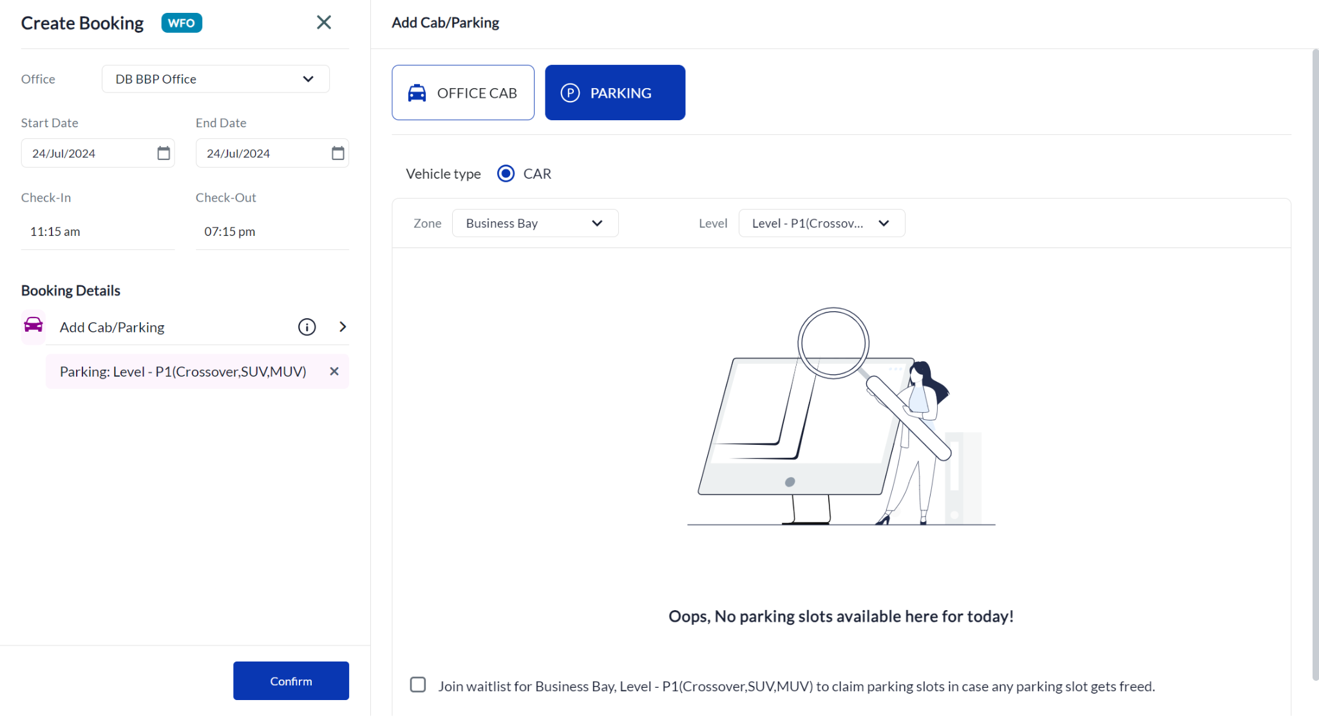
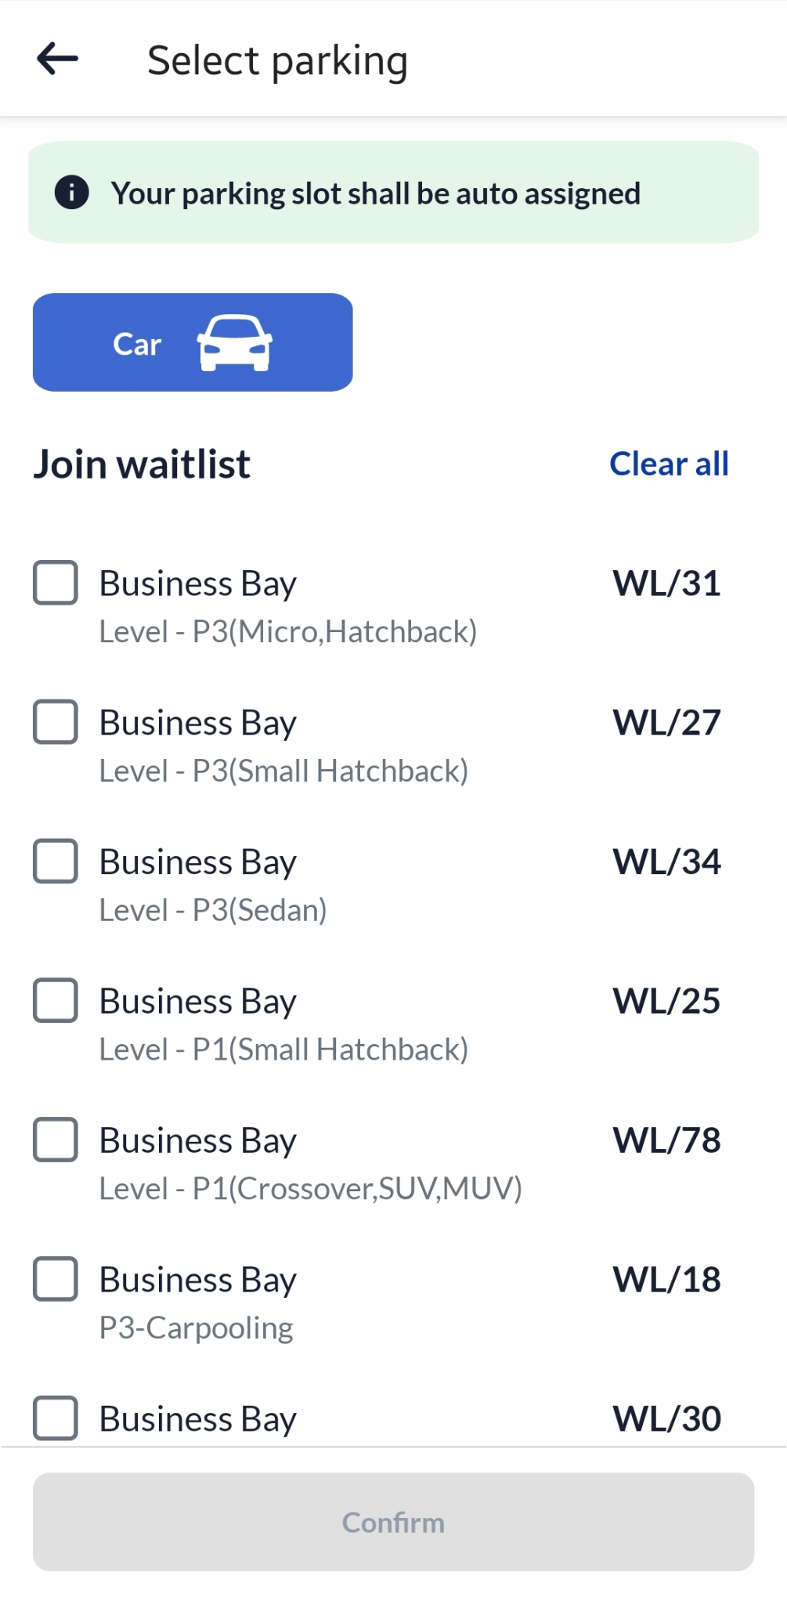

Scenario 2
Join a single waitlist
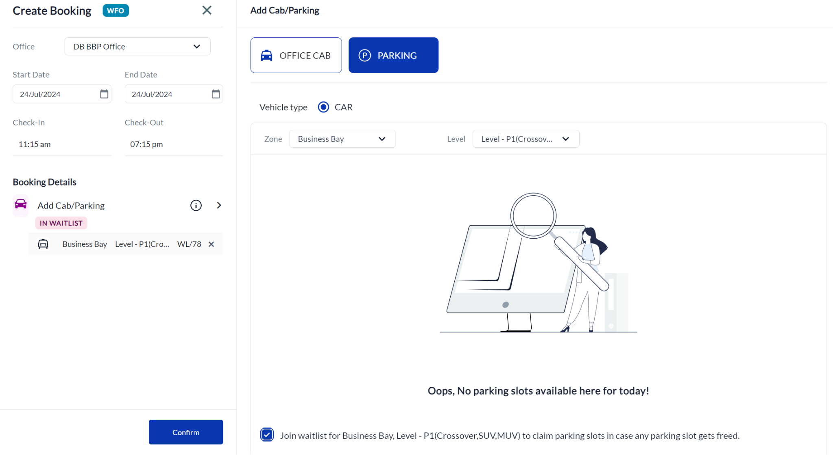

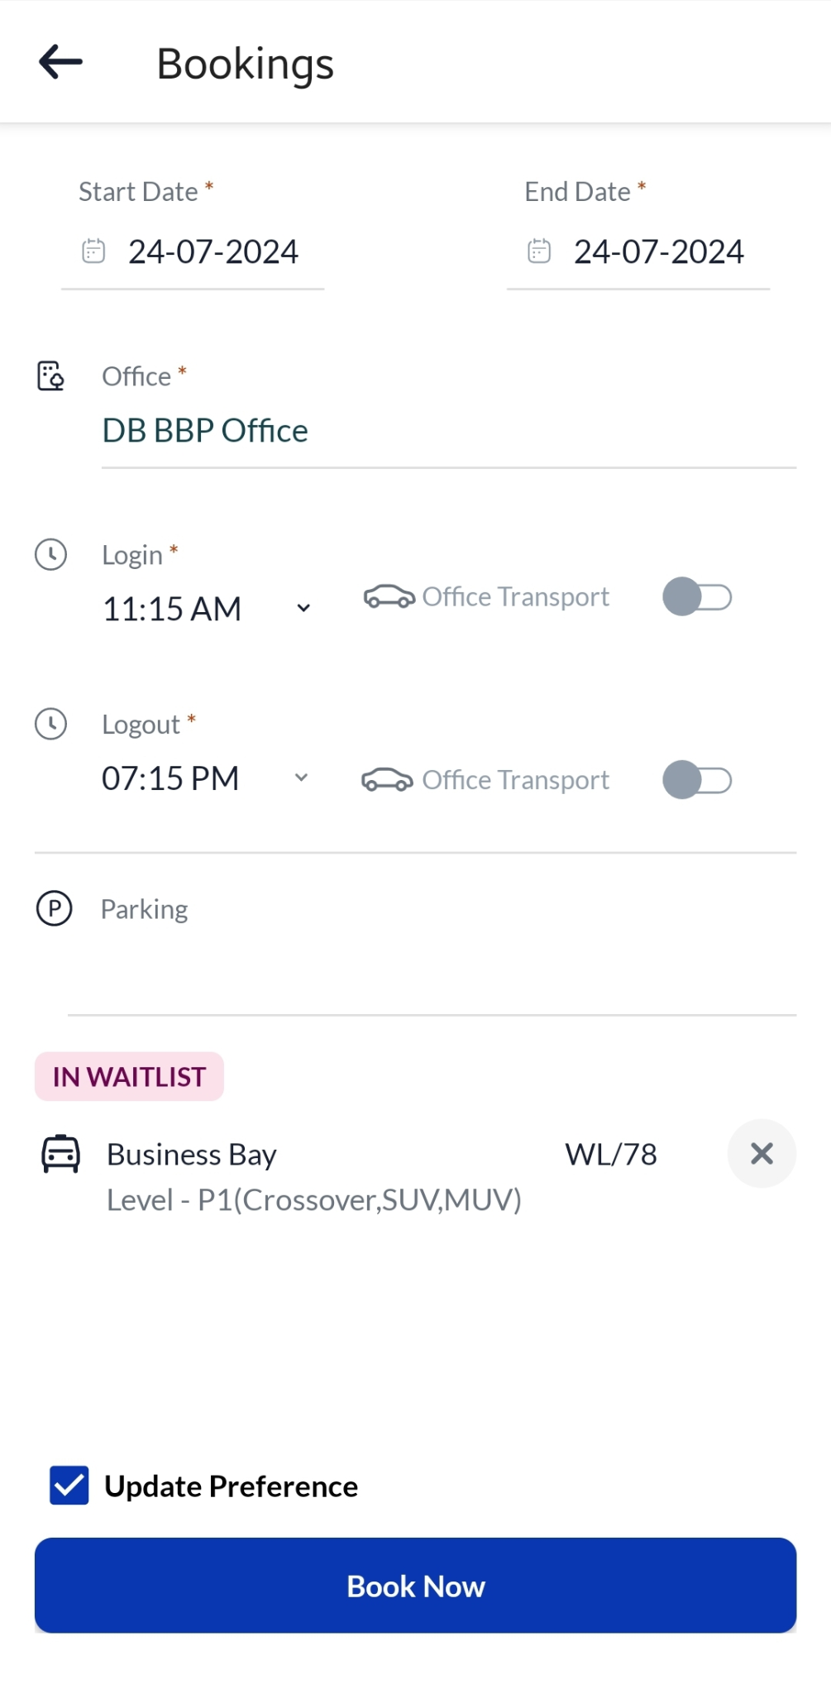

Scenario 3
Join multiple waitlists as per your choice to increase chances of getting a slot
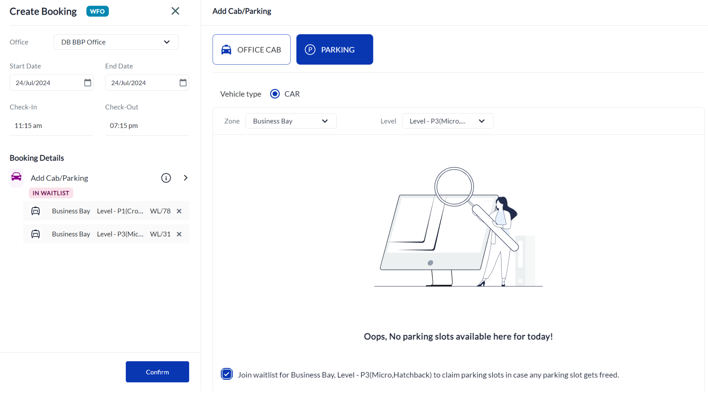
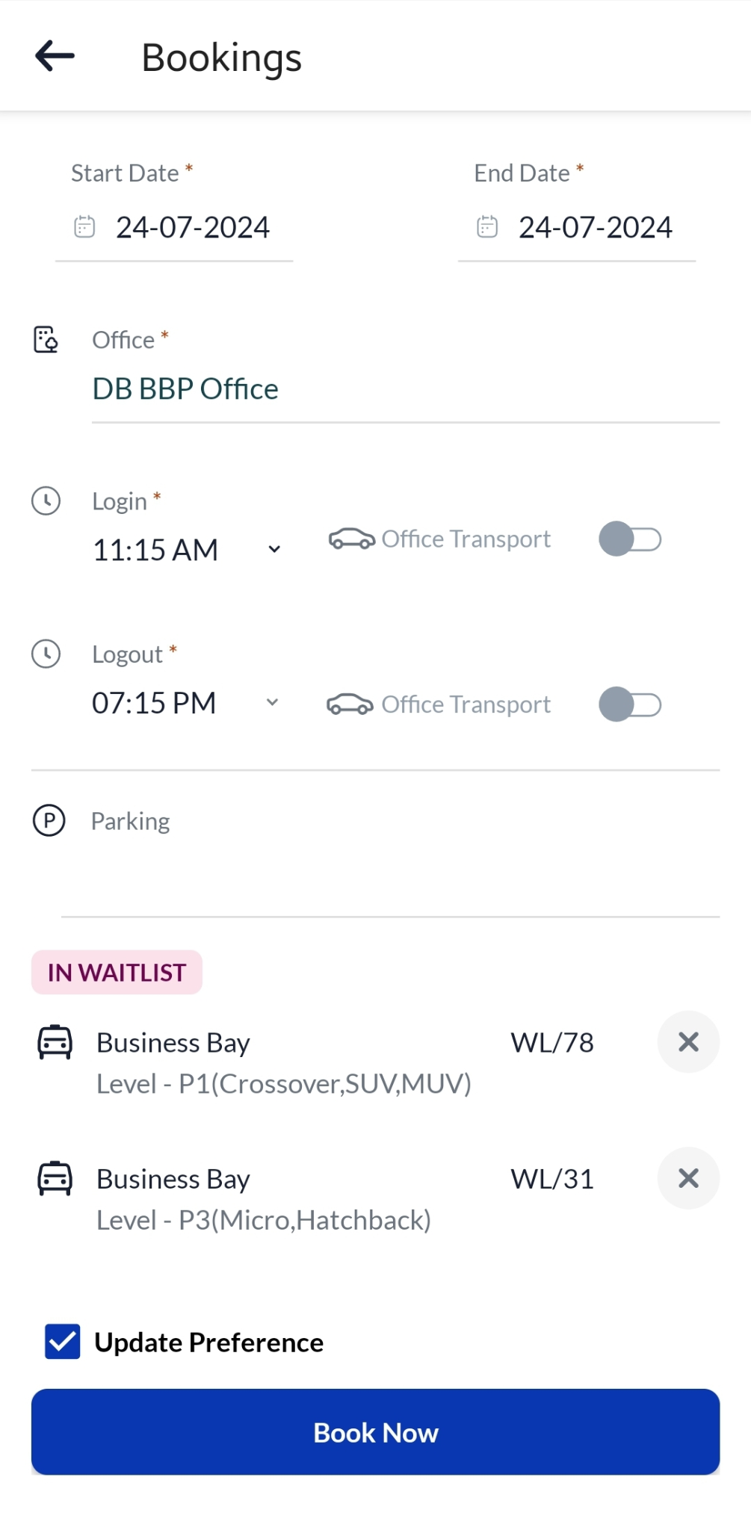

Scenario 4
Book a slot in another level different from your waitlist level in case a slot opens up
